**POINTERS**

Assignment 1

Submitted by:**Sumalinog, Ethan Chav Isaac P.**

Submitted to:**Mr. Nasvin Del Rosario**

**Challenge:**

* Write a program that creates an integer variable with a hard-coded value equal to your student number (5 points).
* Assign that variable address to a pointer variable (5 points).
* Display as output the address of the pointer, the value of the pointer, and the value of what the pointer is pointing to. (20 points)

**Solution:**

My student number is *201911168*. I initialized a variable *int student_number* with the value of *201911168*. I then made a another pointer variable called *\* ptr_student_number*, in which I placed a *NULL* value. I made my pointer variable equal to the address of the student_number. For an added bonus, I outputted the student number first with its variable and its address using the ‘&’ symbol.

I then only used *ptr_student_number* as my variable to be used in different ways to get the specified result. To get the address of the pointer, I used ‘%p’ as the symbol to print the address of the pointer and used the ‘&’ symbol to point out the address of *ptr_student_number*, which is different from the just simply *ptr_student_number*. Afterwards, to get value of *ptr_student_number*, I did the same but without the ‘&’. This points to the address of *student_number*. Lastly, we got the value of the *ptr_student_number* is pointing by knowing what data type it is, which is *int*, then deferencing *ptr_student_number* with using the ‘*’ symbol before the variable. What this does is that it points the value of *student_number* itself, which is *201911168*.

**Code:**

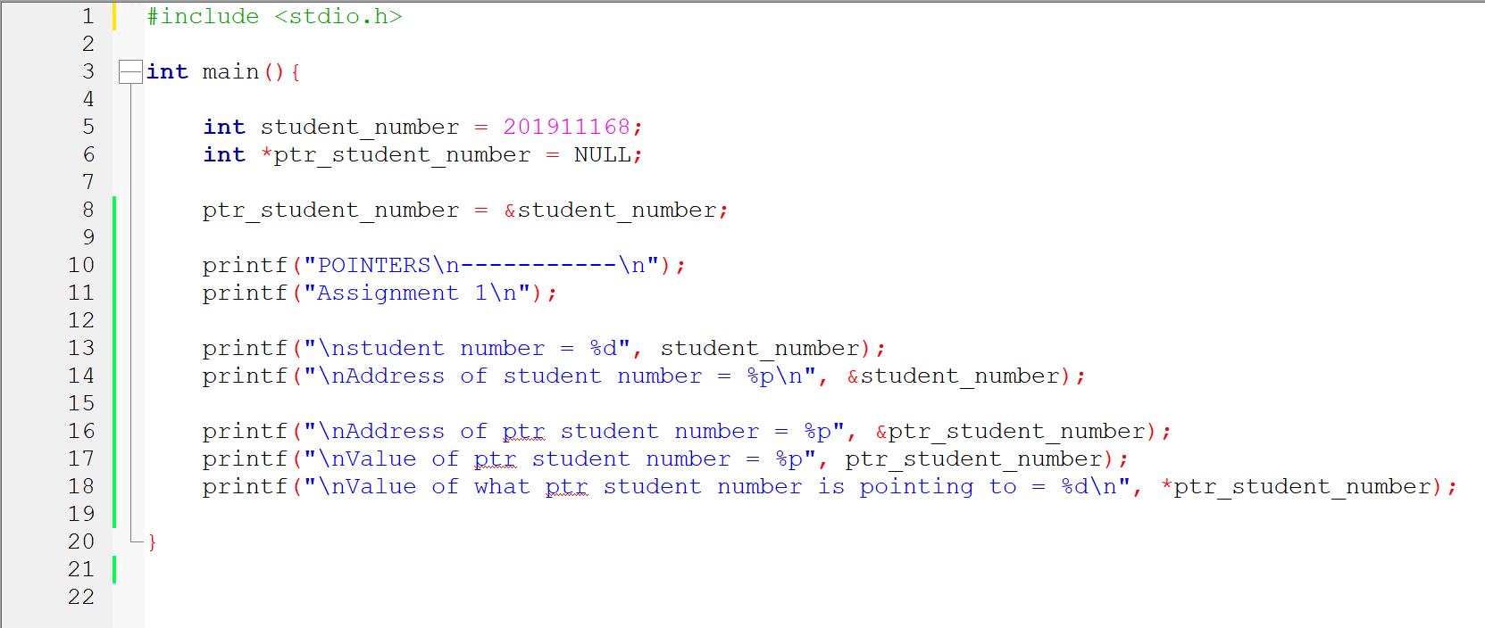

**Output:**

